**ABSTRACT**

**INTRODUCTION**

Event management is a process of organizing a professional and focused event, for a particular target audience. It involves visualizing concepts, planning, budgeting, organizing and executing events such as wedding, musical concerts, corporate seminars, exhibitions, birthday celebrations, theme parties, etc. Event Management is a multi-million dollar industry, growing rapidly, with events hosted regularly. Surprisingly, there is no formalized research conducted to access the growth of this industry. The industry includes fields such as the MICE (Meetings, Incentives and Events), exhibitions, conferences and seminars as well as live music and sporting events. On the profession side, event management is a glamorous and exciting profession that demands a lot of hard work and dynamism. The logistics side of the industry is paid less than the sales/sponsorship side, though some may say that these are two different industries.

Event management is the application of [project management](https://en.wikipedia.org/wiki/Project_management) to the creation and development of large scale events. The process of planning and coordinating the event is usually referred to as event planning and which can include budgeting, scheduling, site selection, acquiring necessary [permits](https://en.wikipedia.org/wiki/License), coordinating transportation and parking, arranging for speakers or entertainers, arranging decor, event security, [catering](https://en.wikipedia.org/wiki/Catering), coordinating with third party vendors, and emergency plans. The events industry now includes events of all sizes from the [Olympics](https://en.wikipedia.org/wiki/Olympics) down to business breakfast meetings. Many industries, [charitable organizations](https://en.wikipedia.org/wiki/Charitable_organization), and interest groups hold events in order to market themselves, build business relationships, raise money, or celebrate achievement. An event refers to a social gathering or activity, such as a festival,( for example a musical festival), a ceremony( for example a marriage ) and a party(for example a birthday party).There are mainly 3 types of event management:

* Corporate Event Management
* Product Launch Event Management
* Special Event Management
  1. **EVENT MANAGEMENT PROCESS**

There are 2 stages of event management process namely, Event planning and Event control.

* Event Planning: To plan an event we must consider the following areas of an event, viz, feasibility, promotion, site choice/design, staging, shutdown, site map, event proposal.
* Event Control: To control an event we must look on the following areas logistics, negotiations, costing & cash flow, event manual, I.T, decision making and change, risk management.
  1. **OBJECTIVE OF THE PROJECT**

The objective of this application is to develop a system that effectively manages all the data related to the various events that take place in an organization. The purpose is to maintain a centralized database of all event related information. The goal is to support various functions and processes necessary to manage the data efficiently.

A feasibility study is a high-level capsule version of the entire System analysis and Design Process. Feasibility is the measure of how well a proposed system solves the problems, and takes advantage of the opportunities identified during scope definition and how it satisfies the requirements identified in system development. A system may serve its intended purpose most effectively when its technical and operating characteristics are engineered into the design. Operational feasibility is a critical aspect of systems engineering that needs to be an integral part of the early design phases. The technical feasibility assessment is focused on gaining an understanding of the present technical resources of the organization.

* 1. **PROPOSED SYSTEM**

This existing system is not providing secure registration and profile management of all the users properly. This system is not providing on-line help. This system doesn’t provide tracking of users activities and their progress. This manual system gives us very less security for saving data and some data may be lost due to mismanagement. This system is not providing event management through internet. This system is not providing proper events information. The system is giving manual information through the event management executer.

**REQUIRED SPECIFICATION**

**TOOLS AND TECHNOLOGIES**

**2.1 HARDWARE REQUIREMENTS**

|  |  |
| --- | --- |
| * Hardware | **:** Processor Intel dual core and above |
| * Clock speed | **:** 3.0 GHz |
| * RAM size | **: 2 GB** |
| * Hard Disk capacity | **:** 400 GB |
| * Monitor type | **: 14,15**  inch color monitor |

**2.2 SOFTWARE REQUIREMENTS**

|  |  |
| --- | --- |
| * Operating System | **:**Windows 10,11 |
| * Internet connection | **:** Existing telephone lines, Data card. |
| * Browser | **:** Google chrome latest version |
| * Database | **:** MySQL. |
| * Performance | **:** The turn-around time of the project will be medium. |
| * Documentation | **:** MS-Office |

**PROPOSED SYSTEM**

Event Management System is an Online event management software project that serves the functionality of an event manager. The system allows only registered users to login and new users are allowed to register on the application. This is a web application but desktop application of the same application is also available. The project provides most of the basic functionality required for an event. It allows the user to select from a list of event types. Once the user enters an event type eg(Marriage, Stage Show etc), the system then allows the user to select the date and time of event, place and the event equipment’s. All this data is logged in the database and the user is setting up his username and password while registering . The data is then sent to the administrator (website owner) and they may interact with the client as per his requirements and his contact data stored in the database.

**3.1 ADVANTAGES**

* The system is useful as it calculates an exact cost for all the resources required during the event.
* The user gets all the resources at a single place instead of wandering around for these.
* This system is effective and saves time and cost of the users.

**DESIGN AND ARCHITECTURES**

**4.1 DESIGN**

Design is the first step in development phase for any techniques and principles for the purpose of defining a device , a process or system in sufficient detail to permit its physical realization. Once the software requirement have been analyzed and specified the software design involves three technical activities-Design, Coding, Implementation, Testing that are required to build and verify the software.The design activities are of main importance in this phase, because in this activities decisions ultimately affecting the success of the software implementation and its ease of maintenance are made. These decision has the final bearing upon reliability and maintainability of the a system. Design is only way to accurately transfer the customers requirements into finished software or system .Design is the place where quality is fostered in development. Software design is the process through which requirements are translated into a representation of software. Software requirement is conducted in two steps. Preliminary design is concerned with the transformation of requirements into data.

**4.2 MODULE DESCRIPTION**

The system after careful analysis has been identified to be presented with the following modules.

**4.2.1 User Module**

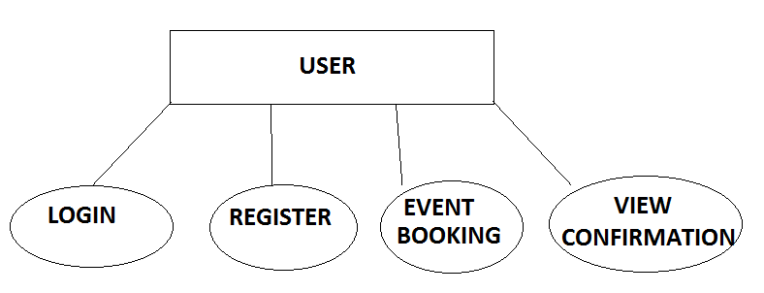

Figure 4.1 User Module

**4.2.2 Administrator Module**

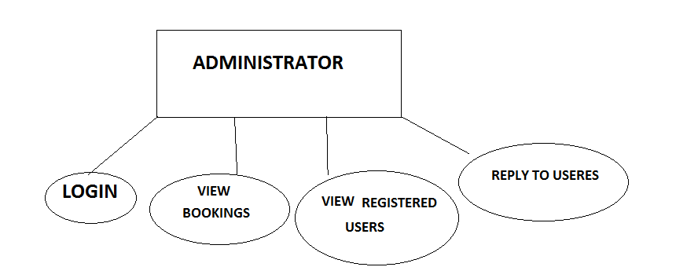

Figure 4.2Adminiistrator Module

**4.3ARCHITECTURE**

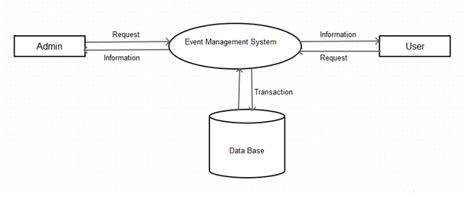

Figure 4.3 Architecture of Event Management System

**4.3.1 ER-Diagram**

An Entity Relationship Diagram (ERD) is a graphical tool to express the overall structure of a database. It is based on a perception of a real world which consists of a set of basic objects. An entity is a person, place, thong or event of interest to the organization and about which data are captured, stored or processed. The attributes are various kinds of data that describes an entity. An association of several entities in an Entity-Relationship model is called relationship.

**CHAPTER 5**

**DEVELOPMENT AND CODING**

**5.1 TECHNOLOGY DESCRIPTION**

**5.1.2 Html**

Hypertext Markup Language (HTML) is the standard [markup language](https://en.wikipedia.org/wiki/Markup_language) for creating [web pages](https://en.wikipedia.org/wiki/Web_page) and [web applications](https://en.wikipedia.org/wiki/Web_application). With [Cascading Style Sheets](https://en.wikipedia.org/wiki/Cascading_Style_Sheets) (CSS) and [JavaScript](https://en.wikipedia.org/wiki/JavaScript) it forms a triad of cornerstone technologies for the [World Wide Web](https://en.wikipedia.org/wiki/World_Wide_Web). [Web browsers](https://en.wikipedia.org/wiki/Web_browser) receive HTML documents from a [web server](https://en.wikipedia.org/wiki/Webserver) or from local storage and render them into multimedia web pages. HTML describes the structure of a web page [semantically](https://en.wikipedia.org/wiki/Semantic) and originally included cues for the appearance of the document.[HTML elements](https://en.wikipedia.org/wiki/HTML_element) are the building blocks of HTML pages. With HTML constructs, [images](https://en.wikipedia.org/wiki/Img_(HTML_element)) and other objects, such as [interactive forms,](https://en.wikipedia.org/wiki/Fieldset) may be embedded into the rendered page. It provides a means to create [structured documents](https://en.wikipedia.org/wiki/Structured_document) by denoting structural [semantics](https://en.wikipedia.org/wiki/Semantics) for text such as headings, paragraphs, lists, [links](https://en.wikipedia.org/wiki/Hyperlink), quotes and other items. HTML elements are delineated by tags, written using [angle brackets](https://en.wikipedia.org/wiki/Bracket#Angle_brackets). Tags such as <img /> and <input /> introduce content into the page directly. Others such as <p>...</p> surround and provide information about document text and may include other tags as sub-elements. Browsers do not display the HTML tags, but use them to interpret the content of the page.HTML can embed programs written in a [scripting language](https://en.wikipedia.org/wiki/Scripting_language) such as [JavaScript](https://en.wikipedia.org/wiki/JavaScript) which affect the behavior and content of web pages. Inclusion of CSS defines the look and layout of content. The [World Wide Web Consortium](https://en.wikipedia.org/wiki/World_Wide_Web_Consortium) (W3C), maintainer of both the HTML and the CSS standards, has encouraged the use of CSS over explicit presentational HTML.

**5.1.3 MySQL**

MySQL  is an [open-source](https://en.wikipedia.org/wiki/Open-source) [relational database management system](https://en.wikipedia.org/wiki/Relational_database_management_system) (RDBMS). Its name is a combination of "My", the name of co-founder [Michael Widenius](https://en.wikipedia.org/wiki/Michael_Widenius)' daughter, and "[SQL](https://en.wikipedia.org/wiki/SQL)", the abbreviation for [Structured Query Language](https://en.wikipedia.org/wiki/Structured_Query_Language). The MySQL development project has made its [source code](https://en.wikipedia.org/wiki/Source_code) available under the terms of the [GNU General Public License](https://en.wikipedia.org/wiki/GNU_General_Public_License), as well as under a variety of [proprietary](https://en.wikipedia.org/wiki/Proprietary_software) agreements. MySQL was owned and sponsored by a single [for-profit](https://en.wikipedia.org/wiki/Business) firm, the [Swedish](https://en.wikipedia.org/wiki/Sweden) company [MySQL AB](https://en.wikipedia.org/wiki/MySQL_AB), now owned by [Oracle Corporation](https://en.wikipedia.org/wiki/Oracle_Corporation).

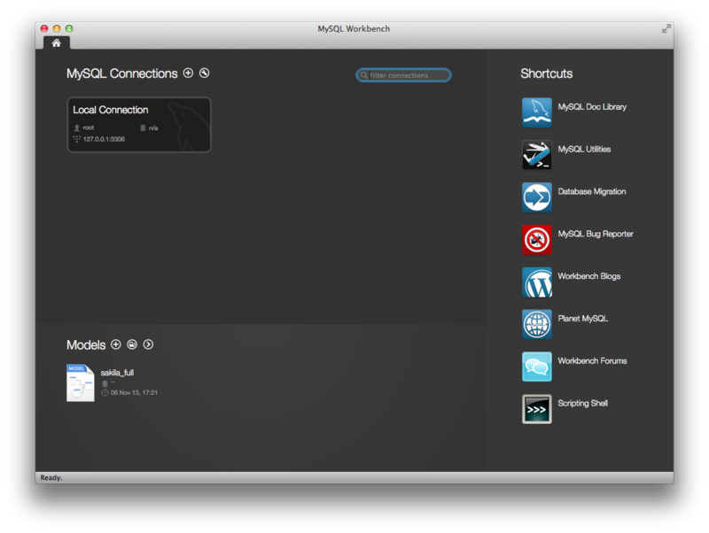

Figure 5.1.3 MySql Workbench running on OS X

For proprietary use, several paid editions are available, and offer additional functionality.MySQL is a central component of the [LAMP](https://en.wikipedia.org/wiki/LAMP_(software_bundle)) open-source web application software stack (and other "[AMP](https://en.wikipedia.org/wiki/List_of_AMP_packages)" stacks). LAMP is an acronym for "[Linux](https://en.wikipedia.org/wiki/Linux), [Apache](https://en.wikipedia.org/wiki/Apache_HTTP_Server), MySQL, [Perl](https://en.wikipedia.org/wiki/Perl)/[PHP](https://en.wikipedia.org/wiki/PHP)/[Python](https://en.wikipedia.org/wiki/Python_(programming_language))". Applications that use the MySQL database include: [TYPO3](https://en.wikipedia.org/wiki/TYPO3), [MODx](https://en.wikipedia.org/wiki/MODx" \o "MODx), [Joomla](https://en.wikipedia.org/wiki/Joomla), [WordPress](https://en.wikipedia.org/wiki/WordPress), [phpBB](https://en.wikipedia.org/wiki/PhpBB" \o "PhpBB), [MyBB](https://en.wikipedia.org/wiki/MyBB" \o "MyBB), and [Drupal](https://en.wikipedia.org/wiki/Drupal). MySQL is also used in many high-profile, large-scale [websites](https://en.wikipedia.org/wiki/Website), including [Google](https://en.wikipedia.org/wiki/Google) (though not for searches), [Facebook](https://en.wikipedia.org/wiki/Facebook), [Twitter](https://en.wikipedia.org/wiki/Twitter), [Flickr](https://en.wikipedia.org/wiki/Flickr), and [YouTube](https://en.wikipedia.org/wiki/YouTube).

**CONCLUSION**